1.

SELECT name

FROM L_Customers;

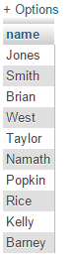

2.

SELECT name

FROM L_Customers

WHERE name like 'J%';



3.

SELECT name

FROM L_Customers

WHERE city like 'B%';



4.

SELECT name

FROM L_Customers

WHERE city = 'Salem';

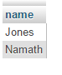

5.

SELECT *

FROM L_Orders

WHERE qty<100;

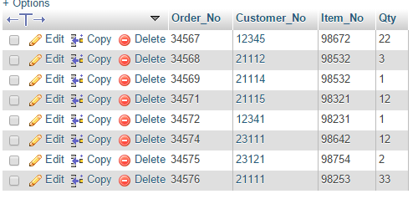

6.

SELECT DISTINCT Customer_No

FROM L_Orders

WHERE qty BETWEEN 1 AND 500;

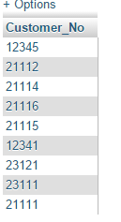

7.

SELECT Customer_No, name, ZIP

FROM L_Customers

WHERE NOT city= 'Boston';

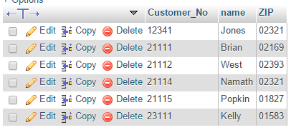

8.

SELECT name as SelectName

FROM L_Customers

WHERE Telephone like '%2_';

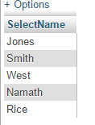

9.

SELECT Customer_No, Order_No, qty

FROM L_Orders

WHERE Item_No like '98___'

ORDER BY qty DESC, Order_No ASC;

